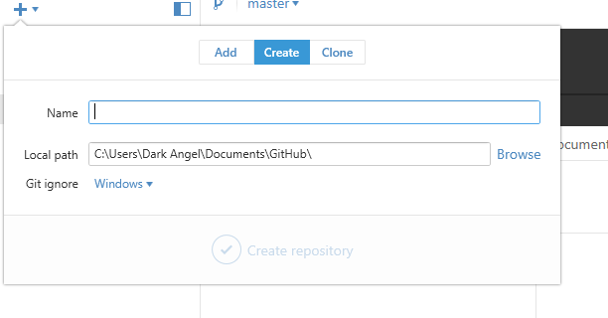

Create repository by using the + on the Gihub on the gihub

then I sync my GiHub with the online GiHub

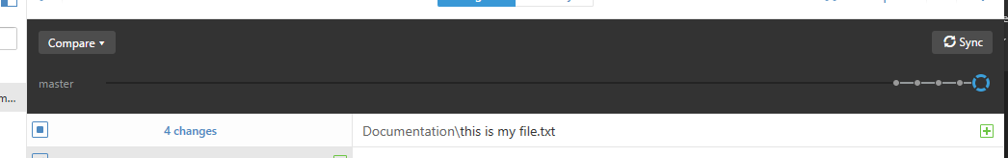

Then I check the website

